Winter Sale — CRM Campaign Brief
HALDEN & ROE · Triggered Email Flow · Winter FY26

1. Campaign Summary
Campaign name | Winter Sale — “The Winter Edit”
Objective | Clear Q1 winter stock and reactivate lapsed VIPs — deliver €480K attributed revenue in an 18-day window.
Channel | Email / CRM — triggered lifecycle flow (ESP-native, no paid media).
Sale window | Fri 26 Dec 2025 → Mon 12 Jan 2026 (18 days); final-72h tier from 09 Jan.
Discount mechanic | Up to 40% off, tiered: 20% launch → 30% mid → 40% final 72h. VIP early access unlocks an extra 10%.
Budget | €14,500 — ESP send volume, creative production, incentive-margin reserve.
Owner / approver | CRM Lead, J. Marlowe · Approver: Head of Ecommerce, P. Adeyemi.
Headline KPIs | 32% open · 4.5% CTR · 2.1% conversion · €480K revenue · unsub <0.25%.

2. Audience & Segmentation
Five priority segments drive the flow; entry and offer tier are set at send time from the CRM. VIP and lapsed cohorts carry P1 weighting — together ~37% of the addressable base but the majority of forecast revenue.
Segment | Definition / criteria | Est. size | Priority
VIP / high-LTV | Top 10% lifetime value; ≥3 orders in 12 mo; AOV > €220 | 4,200 | P1
Lapsed 6–12 mo | Last purchase 180–365 days ago; no order since | 11,800 | P1
Recent browsers | Session < 30 days; viewed sale-eligible categories; no order | 8,600 | P2
First-purchase (0–90d) | One order placed < 90 days ago; not yet repeat | 6,900 | P2
Newsletter-only | Subscribed to CRM; never purchased | 15,400 | P3

3. Offer & Message
THE HOOK  “The Winter Edit is on sale — up to 40% off the pieces you saved.” Scarcity is carried by a tiered, time-boxed markdown, not a blanket code: the discount deepens as stock thins, so early openers get first pick and VIPs get more off. | 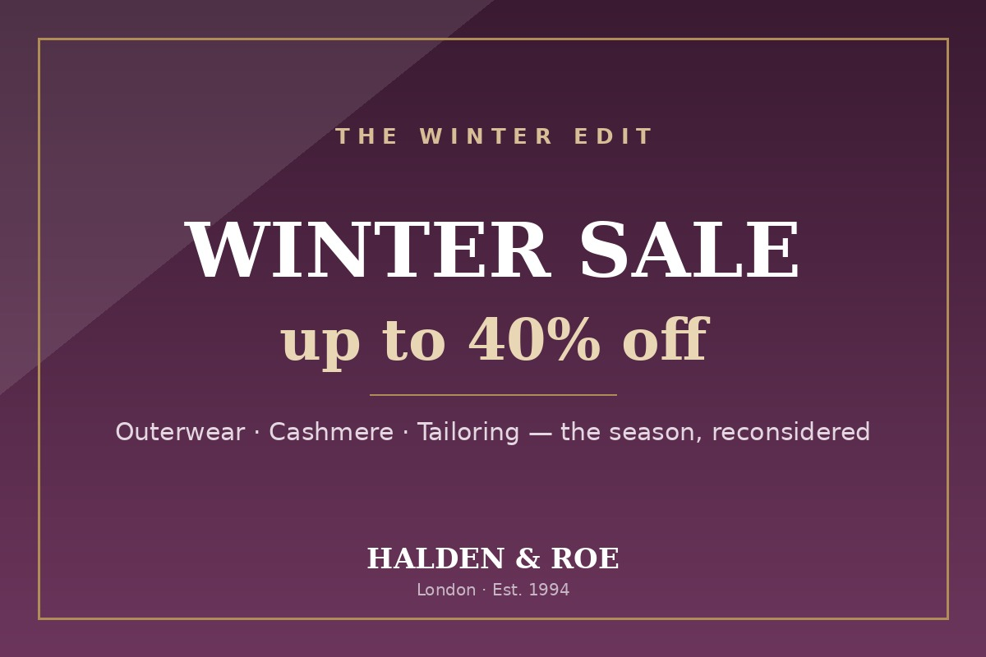  Email hero creative — Winter Sale lockup

Value proposition
Considered winter product — outerwear, cashmere and tailoring — at the season’s best price, with a curated edit that removes the work of hunting a sale. VIPs are rewarded first; lapsed customers get a reason to return before the range sells through.

Tone
Editorial and quiet-confident, never shouty. Urgency comes from the calendar and the tier ladder, not from exclamation marks — the sale reads as an edit, not a clearance bin.

Key messages
- Up to 40% off — the tier deepens as the window closes; the best pieces go first.
- VIP early access with an extra 10%, 24 hours before the public launch.
- Curated by category — outerwear, knitwear, tailoring — not an undifferentiated markdown.
- Free returns and next-day delivery hold through the full sale window.

Exclusions & T&Cs (summary)
Excludes new-season SS26 arrivals, gift cards and archive/collab pieces. Not combinable with other codes; VIP +10% applies to sale price. Discounts apply while stock lasts; prices shown are the sale price. Full terms link in every email footer.

3.1 Email Flow
A four-touch triggered journey with an engagement branch after Email 2: openers are routed to a VIP early-access offer, non-openers to a re-engagement nudge with a fresh subject line.
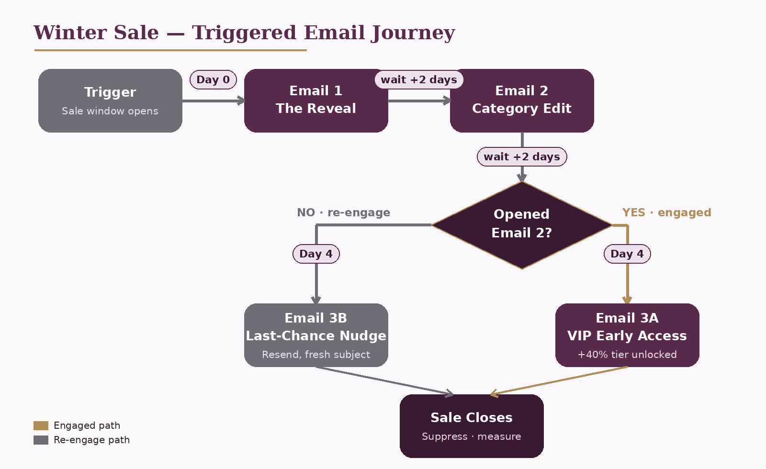
Figure 1 — Winter Sale triggered email journey: trigger → Email 1 (Day 0) → Email 2 (+2 days) → branch on open → Email 3A / 3B (Day 4) → close.

4. Per-Email Content Spec
Content specification for the four emails in the flow. Subject lines carry an A/B test on Emails 1–3; the winner promotes automatically (see §6.2).
Field | Email 1 | Email 2 | Email 3A | Email 3B
Email # | E1 — The Reveal | E2 — Category Edit | E3A — VIP Access | E3B — Last Chance
Send timing | Day 0, 07:00 | Day 2, 07:00 | Day 4 (opened E2) | Day 4 (no open)
Subject A | The Winter Edit is now on sale | Your saved pieces, up to 40% off | Early access: an extra 10%, today only | Ends soon — up to 40% off
Subject B | Up to 40% off the winter edit | Outerwear & cashmere, now reduced | VIP: your extra 10% is live | Last chance before the edit sells out
Preheader | Tiered markdown — best pieces go first | Curated by category — shop the edit | 24 hours, stacked on the sale price | Final tier ends Monday at midnight
Hero concept | Plum lockup, ‘up to 40% off’ | Split hero: outerwear / knit / tailoring | VIP badge, deep-plum ground | Countdown lockup, final tier
Body / offer | Launch tier (20%); the ladder explained | Category rows, dynamic best-sellers | Extra 10% on sale price; VIP SKUs | 40% final tier; low-stock flags
Primary CTA | Shop the sale | Shop outerwear | Unlock my 10% | Shop before it ends
Secondary CTA | See the tier calendar | Browse all categories | Shop the full edit | Save for next drop

5. Personalisation Rules
Dynamic content is resolved per contact at send time from CRM merge fields. Tokens shown in double braces are substituted by the ESP at render.
- Greeting personalises on {{first_name}}; fallback to “Hello” when the field is empty.
- Hero offer swaps by {{loyalty_tier}} — VIPs see the ‘extra 10%’ lockup; all others see the standard tier.
- Product recommendations pull the top 4 SKUs from {{top_category}} browsed or purchased, filtered to sale-eligible stock.
- Lapsed contacts ({{days_since_order}} > 180) receive a “welcome back” band above the hero.
- Countdown block renders {{hours_remaining}} to the current tier; suppressed once the window closes.
- Nearest-store line resolves on {{home_region}} for click-and-collect; hidden when region is unknown.

Dynamic block rules
Content block | Condition | Content served
Hero offer | loyalty_tier = VIP | Extra-10% early-access lockup
Welcome-back band | days_since_order > 180 | “We saved your size” re-entry message
Product recs | top_category is set | 4 best-sellers from that category, sale-only
Countdown | hours_remaining > 0 | Live tier countdown; else hidden

6. Success Metrics & Test Plan

6.1 Targets
Metric | Target | Benchmark | Driver
Open rate | 32% | 26% house avg | Subject A/B + 07:00 send
Click-through (CTR) | 4.5% | 3.1% | Hero + single primary CTA
Conversion | 2.1% | 1.4% | Tiered urgency, final 72h
Attributed revenue | €480K | €360K (SS25 sale) | 18-day window, 4 sends
Unsubscribe rate | < 0.25% | 0.31% | Frequency cap at 4 sends

6.2 Test Plan
Test | Hypothesis | Split | Decision rule
Subject line (E1) | Benefit-led beats curiosity-led | 50 / 50 | Promote winner at 95% sig.
Send time (E2) | 07:00 lifts opens vs 18:00 | 50 / 50 | or after 5,000 sends
Offer framing (E3A) | “Extra 10%” beats “early access” | 50 / 50 | Winner rolls to full send

7. Compliance & Governance
All sends run against UK/EU direct-marketing rules; the controls below are verified before the flow is switched live.
Requirement | Basis / control | Status
Consent basis | Soft opt-in (PECR reg. 22) + GDPR Art. 6(1)(f) legitimate interest | ✔
Unsubscribe | One-click List-Unsubscribe header + footer link; honoured < 24h | ✔
Sender identity | From: Halden & Roe <hello@halden-roe.com>; postal address in footer | ✔
Data retention | Engagement data held 24 months, then anonymised | ✔
Suppression list | Global unsub + hard-bounce + complaint scrub applied pre-send | ✔
Frequency cap | Max 4 sale sends per contact across the 18-day window | ✔

8. Asset Checklist
Asset | Spec / dimensions | Owner | Due | Status
Hero banner | 1200×800px, < 200KB, plum lockup | Studio | 18 Dec | ✔
Email templates ×4 | 600px width, dark-mode safe | CRM Dev | 20 Dec | ✔
Subject-line matrix | A/B variants ×3 emails | Copy | 19 Dec | ✔
Product feed | 24 SKUs, sale price + strikethrough | Merch | 19 Dec | Pending
Segmentation export | 5 segments, CSV to ESP | Data | 22 Dec | Pending
Landing page | /winter-sale, tiered banner | Web | 21 Dec | Pending
Approved for build: ______________________________ Head of Ecommerce Date: ____________ Version v1 · Marketing

