Consumer Cultures in Luxury Markets

Authenticity, Access, and the Circular Wardrobe
Generation Z Attitudes to Resale in Luxury Fashion

A research report submitted in partial fulfilment of the
requirements of module FASH-4207
Eleanor M. Whitcombe
Student ID 2041887
Department of Fashion Business and Cultural Studies
University of Ashcombe
Supervisor: Dr M. Farrow-Leigh
Word count: 4,180 (excluding references and appendix)
Submitted 15 May 2026

Abstract
The resale of luxury fashion has moved from the margins of the second-hand trade to a central pillar of the industry, and Generation Z is widely credited as its principal engine. This report examines the attitudes that underpin Gen-Z participation in luxury resale, asking what motivates purchase and consignment, what reservations persist, and how these consumers reconcile status, thrift, and sustainability within a single wardrobe. Drawing on a SAMPLE cross-sectional survey of 412 respondents aged 18 to 26 and a small set of follow-up interviews, the study finds that access to scarce and archival pieces, price relative to primary retail, and circular-economy values are the dominant motivations, while concerns over authentication and platform trust remain the principal barriers. The findings are interpreted against the literature on access-based consumption and conspicuous sustainability, and are situated within the wider democratisation of luxury. The report concludes that resale is not, for these consumers, a compromise on luxury but a distinct and values-driven mode of acquiring it, and offers recommendations for brands and platforms seeking to serve the segment credibly. All figures reported here are illustrative sample data and should not be read as market measurements.
Keywords: Generation Z; luxury resale; second-hand fashion; authenticity; sustainability; access-based consumption; circular economy.

Contents

Introduction
Over the past decade the market for pre-owned luxury goods has grown several times faster than the primary market, and industry analysts now treat resale as a structural feature of the sector rather than a cyclical curiosity (Bain & Company, 2023). Much of this momentum is attributed to younger consumers: ThredUp (2023) reports that shoppers under the age of twenty-six account for a disproportionate share of resale transactions, and Kapoor and Njoku (2023) describes the second-hand wardrobe as a defining consumption practice of the generation. Yet the attitudes that drive this behaviour remain imperfectly understood, and are too readily reduced to price sensitivity alone.
This report sets out to examine those attitudes directly. Its aim is to characterise how Generation Z consumers understand and justify their participation in luxury resale, and to test whether that participation is best explained by thrift, by values, by the pursuit of status, or by some combination of the three. As Delgado (2021) argues, resale sits at an unusually dense intersection of economic, ethical, and identity concerns, which makes it a productive site for studying contemporary luxury consumption more broadly.
The study is organised around three research questions:
- What motivates Generation Z consumers to buy and to consign luxury goods on resale platforms?
- What reservations or perceived risks constrain that participation?
- How do these consumers reconcile status, economy, and sustainability within their account of resale?
The remainder of the report reviews the relevant literature, sets out the sample method and its limitations, presents the results, and interprets them before offering recommendations for practice.

Literature review
The scholarship relevant to this study falls into three overlapping strands: the growth and structure of the luxury resale market, the values that Generation Z brings to consumption, and the theories of status and access that explain why ownership itself is being reappraised. Each is reviewed in turn.

The rise of luxury resale
The expansion of the resale market is by now well documented. Bain & Company (2023) estimates that the global pre-owned luxury market has continued to outpace the primary market, a trajectory Williams (2021) attributes in large part to digital platforms that lowered the search and authentication costs which had long suppressed second-hand demand. Ferrand et al. (2023) frames this shift as a democratisation of luxury: platforms make scarce and archival pieces visible and attainable to consumers who would never encounter them in a boutique, unbundling the good from the primary-retail ritual that once surrounded it. Laurent (2021) cautions, however, that growth figures conceal wide variation across categories, with handbags and watches behaving as quasi-investment assets while ready-to-wear depreciates conventionally.

Gen-Z values: authenticity and sustainability
A second strand locates resale within the distinctive value profile of Generation Z. Kapoor and Njoku (2023) characterise these consumers as operating a moral economy of fashion in which environmental and ethical considerations are not peripheral but constitutive of what counts as desirable. Delgado (2021) links this directly to circular consumption, arguing that buying pre-owned allows young consumers to participate in luxury while narrating that participation as responsible. Such accounts should be read with care: Patel (2020) warns of conspicuous sustainability, in which the signalling value of appearing ethical can outweigh measurable environmental benefit, and Chen and Ortiz (2022) similarly finds that authenticity claims are themselves a form of social signalling rather than a simple report of inner conviction.

Status, access, and the circular wardrobe
The third strand reframes the question of ownership itself. Grewal and Hoffmann (2020) develop the concept of status consumption within the sharing economy, showing that access to desirable goods can confer distinction even when durable ownership is absent or temporary. Sorensen and Wang (2022) extend this through the theory of access-based consumption, arguing that for many younger consumers the meaning once carried by owning an object is increasingly carried by curating a rotating, resellable collection. On this account the resale platform is not merely a cheaper shop but an infrastructure for a circular wardrobe in which pieces are held, enjoyed, and released. Trust in that infrastructure is decisive: Iversen (2022) and Nordqvist and Bauer (2023) both identify provenance, authentication, and platform reputation as the conditions under which access-based luxury consumption can function at all.

Methodology
The study adopted a cross-sectional, mixed-methods design intended to characterise attitudes at breadth while retaining some interpretive depth. The primary instrument was a self-administered online questionnaire; a small set of semi-structured follow-up interviews was used to contextualise the quantitative pattern. The design follows the pragmatic tradition in consumer research and makes no claim to a representative probability sample.
A SAMPLE of 412 respondents aged between 18 and 26 was recruited through university networks and social-media panels. Respondents were required to have bought or sold at least one luxury item on a resale platform in the preceding twelve months. The questionnaire combined five-point Likert items on motivations and barriers with categorical items on platform use and category. Twelve respondents were subsequently interviewed. Because recruitment was non-probabilistic and self-selected, the results are treated throughout as illustrative rather than as population estimates, and all reported percentages are labelled as sample data; an excerpt of the survey instrument is reproduced in the appendix.
The twelve interviews followed a semi-structured protocol lasting between twenty and thirty-five minutes. Participants were asked to narrate a recent resale purchase or consignment in their own words before being prompted on motivation, trust, and the place of sustainability in their reasoning. This sequence was deliberate: opening with an unprompted account reduced the risk that respondents would simply echo the socially approved language of environmental virtue, allowing the analysis to distinguish volunteered motives from those offered only under prompting.
Quantitative responses were summarised descriptively, while interview material was analysed thematically to surface the interpretive frames respondents used to justify their behaviour. Ethical approval was obtained from the departmental research ethics committee. Participation was voluntary and uncompensated, informed consent was secured before data collection, responses were anonymised at the point of capture, and participants could withdraw at any stage. The chief limitations, discussed later, are the sample's skew toward students and its reliance on self-reported attitude rather than observed behaviour, a gap Patel (2020) notes is endemic to values-based consumption research.

Findings
The results are reported in two parts: the motivations respondents gave for participating in luxury resale, and the barriers that constrained that participation. Figures and the table below present the sample data; all values are illustrative.

Motivations for resale participation
When asked to identify the factors that mattered most in their decision to buy pre-owned luxury, respondents most frequently cited access to scarce or archival pieces, followed closely by price relative to primary retail and by sustainability. Figure 1 summarises the distribution. Notably, access outranked price for this sample, consistent with the account of the circular wardrobe advanced by Sorensen and Wang (2022) and with the democratisation thesis of Ferrand et al. (2023).
The lower-ranked motivations are as revealing as the leading ones. Investment and resale value, though selected by a substantial minority, were seldom described as the primary reason for a given purchase; respondents treated resale value as a reassuring property of the object rather than the point of acquiring it. Distrust of fast fashion, the least selected of the six prompts, functioned less as an active motivation than as a background disposition against which the appeal of durable, resellable pieces was set.
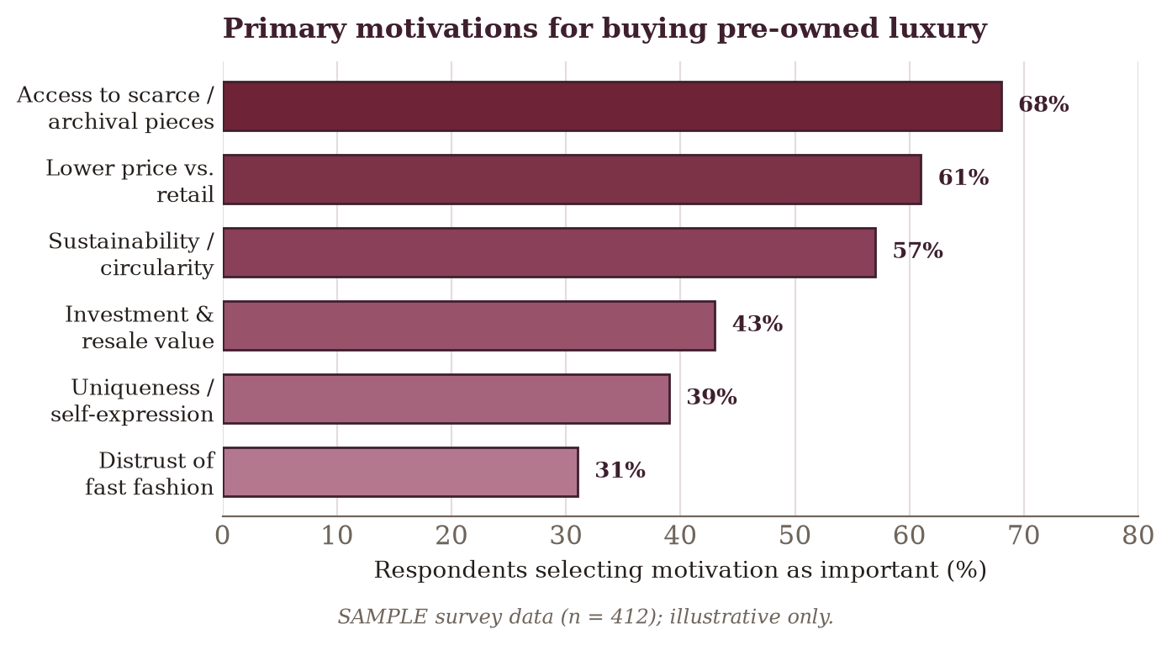
Figure 1. Primary motivations for buying pre-owned luxury (SAMPLE survey data, n = 412; illustrative only).
The interview material added texture to this pattern. Respondents repeatedly described resale as a way of assembling a personal, non-replicable wardrobe: the object's prior life was framed not as a defect but as part of its value, echoing the authenticity signalling described by Chen and Ortiz (2022). A studio plate of a representative consigned piece is shown in Figure 2.
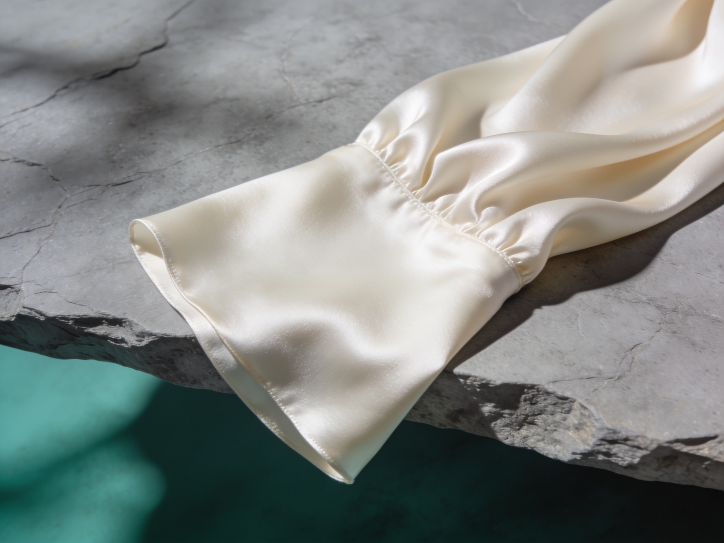
Figure 1. Studio plate of a representative consigned garment (illustrative sample image; not part of the survey data).

Barriers and trust
The barriers respondents reported were dominated by questions of trust. Table 1 sets out the share of the sample rating each barrier as important. Doubt over authenticity was the most widely held concern, followed by uncertainty about item condition and by the reputation of the platform itself, a ranking that closely tracks the provenance-and-authentication conditions identified by Iversen (2022) and Nordqvist and Bauer (2023).
Reported barrier | Rated important (%) | Interpretive frame
Authenticity / counterfeit risk | 64 | Provenance and trust
Uncertain item condition | 52 | Information asymmetry
Platform reputation | 44 | Institutional trust
Slow or complex returns | 29 | Transaction friction
Social stigma of second-hand | 12 | Residual, declining
Table 1. Reported barriers to luxury resale participation (SAMPLE survey data, n = 412; illustrative only).
Taken together, the two figures and the table describe a segment that is strongly motivated but conditionally so: willing to participate where trust is underwritten, and quick to withdraw where it is not.

Platform use and category patterns
Two further patterns in the sample warrant brief comment, both consistent with the wider literature. First, respondents typically used more than one platform, distinguishing between them by the categories each was trusted to authenticate: structured goods such as handbags and watches were routed to platforms with visible authentication guarantees, while ready-to-wear moved more freely across peer-to-peer marketplaces. This category-dependent allocation of trust mirrors the variation Laurent (2021) observes across resale segments and reinforces the reading, developed below, that trust is the organising variable of the practice rather than one concern among several.
Second, consignment and purchase were rarely experienced as separate acts. A majority of respondents who had bought pre-owned had also consigned within the same period, and several described funding new acquisitions directly from the proceeds of pieces they had released. This rotation, in which the wardrobe is continually refreshed without a net accumulation of possessions, is the practical form of the circular wardrobe that Sorensen and Wang (2022) theorise, and it frames the recommendations that follow.

Discussion
The pattern in the results speaks directly to the three research questions. On motivation, the primacy of access over price is the most striking result and the hardest to square with a purely economising account of second-hand consumption. It supports instead the access-based reading of Sorensen and Wang (2022), in which the resale platform functions as the infrastructure of a circular wardrobe rather than as a discount channel, and it is consistent with the democratisation thesis of Ferrand et al. (2023): what respondents valued was the reachability of pieces that primary retail rations by scarcity.
On reservation, the dominance of authenticity and platform trust confirms the conditions Iversen (2022) and Nordqvist and Bauer (2023) place at the centre of a functioning resale market. Trust is not a peripheral friction to be smoothed but the precondition on which the whole practice rests; where it is absent, motivation does not translate into transaction. This has a clear practical corollary, developed in the recommendations below.
On the reconciliation of status, economy, and sustainability, the results caution against taking respondents' stated values at face value. Sustainability ranked highly, yet the qualitative material suggested that it often co-existed with, and was sometimes rationalised after, motives of access and distinction, exactly the conspicuous sustainability Patel (2020) describes and the signalling dimension Chen and Ortiz (2022) identifies in authenticity claims. The status mechanism of Grewal and Hoffmann (2020) is not displaced by sustainability so much as recoded through it: buying pre-owned lets these consumers claim distinction and virtue at once. This interpretation aligns with the broader repositioning of luxury value traced by Laurent (2021) and echoed across the industry outlook of McKinsey & Company (2022).
Beyond the immediate questions, the pattern has a bearing on how luxury value itself is theorised. If access rather than ownership is what these consumers principally seek, then the classical account of luxury as the durable possession of a scarce object is only partial. The findings suggest a complementary reading in which value inheres in the ability to move through a sequence of desirable objects, holding each provisionally, and in which the resale platform is the institution that makes such circulation legible and safe. This does not dissolve status into thrift; rather, as the interviews made plain, it fuses distinction, economy, and virtue into a single practice that is difficult to disentangle by survey item alone. Read this way, the sustainability motive is neither cynical nor decisive on its own; it is the vocabulary through which a more complex set of desires is made speakable.
Two limitations qualify these readings. The sample was self-selected and student-weighted, so the strength of the sustainability and access motives may be inflated relative to the wider Gen-Z population; and the study measured reported attitude rather than observed behaviour, leaving the familiar attitude-behaviour gap unresolved. Both temper the generalisations that can be drawn, and both point to the value of behavioural and longitudinal work.

Conclusion and recommendations
This report set out to characterise Generation Z attitudes to resale in luxury fashion. The evidence, though drawn from an illustrative sample, points to a consistent conclusion: for these consumers resale is not a diminished form of luxury but a distinct and values-inflected way of acquiring it, driven above all by access, enabled by trust, and narrated through sustainability. The practice is better understood through the lens of access-based consumption than through price alone, and its central vulnerability is the fragility of trust on which it depends. On that basis the report offers the following recommendations for brands and platforms seeking to serve the segment.
- Treat authentication as a core service, not a compliance cost: make provenance and condition verifiable, visible, and warranted at the point of purchase, since trust is the binding constraint on participation.
- Design for the circular wardrobe by supporting easy consignment and buy-back, so that acquisition and release are a single continuous relationship rather than two disconnected transactions.
- Communicate sustainability with evidence rather than assertion, recognising that this audience is both drawn to and sceptical of environmental claims.
- Curate for access, foregrounding scarce and archival pieces that primary retail cannot supply, since reachability outweighed price in this sample.
- Segment authentication guarantees by category, matching the depth of verification to the risk each product type carries, since respondents already route categories to platforms on precisely this basis.
- Commission behavioural and longitudinal research to close the attitude-behaviour gap that self-reported studies, including this one, cannot resolve.

References
Bain & Company (2023) The Global Luxury Resale Report 2023. Milan: Bain & Company.
Chen, L. and Ortiz, M. (2022) 'Authenticity signalling in second-hand luxury consumption', Journal of Consumer Culture, 22(3), pp. 401-420.
Delgado, R. (2021) The Circular Wardrobe: Sustainability and Style Among Young Consumers. London: Meridian Press.
Ferrand, C., Osei, K. and Blomqvist, T. (2023) 'Digital resale platforms and the democratisation of luxury', International Journal of Fashion Studies, 10(2), pp. 145-167.
Grewal, D. and Hoffmann, J. (2020) 'Status consumption in the sharing economy', Journal of Marketing Theory and Practice, 28(4), pp. 512-529.
Iversen, S. (2022) 'Trust, provenance and the pre-owned luxury market', Fashion Practice, 14(1), pp. 33-55.
Kapoor, A. and Njoku, E. (2023) 'Generation Z and the moral economy of fashion', Young Consumers, 24(2), pp. 210-228.
Laurent, P. (2021) Luxury Reimagined: Value, Scarcity and the New Consumer. Paris: Atelier Editions.
McKinsey & Company (2022) The State of Fashion 2022. New York: McKinsey & Company.
Nordqvist, H. and Bauer, F. (2023) 'Platform trust and authentication in online resale', Electronic Commerce Research, 23(1), pp. 77-99.
Patel, N. (2020) 'Conspicuous sustainability: signalling values through consumption', Journal of Business Ethics, 165(2), pp. 289-305.
Sorensen, K. and Wang, Y. (2022) 'Access-based consumption and the meaning of ownership', Journal of Consumer Research, 49(2), pp. 260-281.
ThredUp (2023) Resale Report 2023. Oakland, CA: ThredUp.
Williams, G. (2021) 'Digitally native consumers and the future of retail', Journal of Retailing and Consumer Services, 60, pp. 102-115.

Appendix
Appendix A. Survey instrument (excerpt)
The following items are reproduced from the SAMPLE questionnaire administered to respondents. Motivation and barrier items were rated on a five-point scale from 1 (not at all important) to 5 (extremely important).
- In the last 12 months, how many luxury items have you bought or sold on a resale platform? (0 / 1-2 / 3-5 / 6 or more)
- How important was each of the following in your decision to buy pre-owned: access to scarce pieces; lower price; sustainability; resale value; uniqueness; distrust of fast fashion? (1-5)
- How important was each of the following as a concern: authenticity; item condition; platform reputation; returns; social stigma? (1-5)
- Which platforms have you used in the last 12 months? (select all that apply)
- In your own words, what does buying second-hand luxury mean to you? (free text)
Appendix B. Interview topic guide (excerpt)
The semi-structured interviews opened with an unprompted account before moving through the prompts below. Probes were used flexibly and are not reproduced here. The guide is included to document the basis on which the thematic analysis was conducted.
- Please describe the most recent luxury item you bought or sold second-hand, from first noticing it to completing the transaction.
- What made this piece worth acquiring, or worth letting go of, at that moment?
- How did you decide which platform to use, and what gave you confidence in it?
- How, if at all, did sustainability enter into your thinking about the purchase?
- Would you describe buying pre-owned as different in kind from buying new? In what way?
- How do you expect your use of resale to change over the next few years?
Note. All numerical values reported in this document are illustrative SAMPLE data generated for the purposes of this example report and do not represent an actual market survey. The instrument and topic guide above are reproduced in abbreviated form; the full protocol is held with the departmental ethics record.

