Fit Session Report
Ellory & Vane · Bespoke & Made-to-Measure · No. 14 Savile Row, London
Garment ref. | EV-27J-0142 / Single-breasted 2-button lounge jacket
Style no. | AW27-BR-JKT-014 (“The Marlborough”)
Cloth | Fox Brothers 13oz charcoal herringbone, 100% worsted wool (lot 8842)
Sample size | 40R · block: EV House Draft B (drop 6)
Fitter | J. Ellory (Head Fitter) · Cutter: T. Vane
Model / fit spec | House fit form 40R + client last (D. Ashcombe) · standard posture
Fitting | First basted fitting · Session 1 of 3
Date / season | 14 July 2026 · Autumn/Winter 2027

OVERALL VERDICT  REVISE | Sample is sound in cloth and construction but not yet passable: three points of measure sit outside working tolerance and the balance reads front-heavy. Corrections are contained and achievable inside one iteration — re-cut of the sleeve, a waist let-out, and a gorge/collar re-set — so the piece is returned for a second basted fitting rather than rejected.

Fit summary
On the form the jacket hangs clean through the chest and the herringbone matches at the centre-back seam and across both quarters. The revise call is driven by fit geometry, not make. The waist is a full 1.4 cm over spec on the half-measure, collapsing the intended suppression and letting the front blades stand away; the right sleeve reads 1.3 cm short from the centre-back, breaking the cuff line against the shirt; and the gorge has crept 0.9 cm high and open, pushing the lapel roll off the intended break. None of these is structural — each is a marking or pressing correction — but together they carry the sample below a passable first fitting. Detailed measures and zone commentary follow.

Points of Measure — measured against spec
All values in centimetres on the half-measure unless noted. Deviation = sample − spec. A point is flagged OUT OF TOL when |deviation| exceeds the stated tolerance.
POM | Description | Spec | Sample | Tol ± | Dev. | Status
A01 | Chest, 1/2 (2.5 cm below armhole) | 52.0 | 52.4 | 0.6 | +0.4 | ● OK
A02 | Waist, 1/2 (at fore-button) | 47.0 | 48.4 | 0.8 | +1.4 | ● OUT OF TOL
A03 | Hem sweep, 1/2 | 54.0 | 54.3 | 0.8 | +0.3 | ● OK
B01 | Shoulder, seam to seam | 45.0 | 45.2 | 0.5 | +0.2 | ● OK
B02 | Across back, 1/2 | 20.5 | 20.6 | 0.5 | +0.1 | ● OK
C01 | Sleeve length, CB to cuff (R) | 84.5 | 83.2 | 0.6 | −1.3 | ● OUT OF TOL
C02 | Cuff opening | 14.5 | 14.6 | 0.4 | +0.1 | ● OK
C03 | Bicep, 1/2 | 20.0 | 20.3 | 0.5 | +0.3 | ● OK
D01 | Back length, HPS to hem | 76.0 | 76.4 | 0.6 | +0.4 | ● OK
D02 | Front length, HPS to hem | 74.5 | 74.7 | 0.6 | +0.2 | ● OK
E01 | Gorge height, neck-point to notch | 8.5 | 9.4 | 0.4 | +0.9 | ● OUT OF TOL
E02 | Lapel width at widest | 8.5 | 8.6 | 0.3 | +0.1 | ● OK

Corrections requested
A02 — Waist. Let out is not the fix; the suppression was marked shy. Re-mark the side-body and back seams to recover 1.4 cm of shape at the fore-button and re-press the waist curve. Confirm the drape closes over the hip.
C01 — Sleeve length (R). Right sleeve set 1.3 cm short. Re-cut from the sleeve-head reserve and re-hang; verify pitch at the same time (see zone notes). Left sleeve is in tolerance — do not disturb.
E01 — Gorge / collar. Gorge is high and open by 0.9 cm. Drop the notch and re-set the collar to lower the break point one button; re-press the lapel roll to a soft 3-roll-2.

Balance & Aesthetic — by body zone

Collar & neckline
The collar sits close at the centre-back with no gap, but rides high on the right neck-point where the gorge has crept. Once the gorge is re-set the collar band should settle a clean 1.5 cm of shirt-collar showing. No wrinkling at the fold line.

Shoulder & back balance
Shoulder line is clean and the pad sits without divot; across-back is in tolerance. A faint diagonal drag runs from the right shoulder-blade toward the under-arm — consistent with the short right sleeve pulling the scye — and should release once the sleeve is re-hung.

Chest & lapel roll
Chest is full and honest with no break under the arm. The lapel roll is the weak point: the high gorge forces the break above the intended point, standing the lapel proud of the chest. Re-setting the gorge and pressing a soft roll recovers the line.

Waist suppression
The dominant fault. At 1.4 cm over spec the waist is effectively un-suppressed, so the fronts stand away and the skirt loses its intended clean sweep over the seat. This is a marking correction, not a let-in, and drives the revise verdict.

Sleeve pitch & length
Right sleeve is both short (−1.3 cm) and pitched a touch forward, throwing a soft fold on the fore-arm. Re-cut for length and re-hang to correct pitch in one operation. Left sleeve hangs true — use it as the reference.

Skirt, vents & hem
Double vents hang closed at rest and the hem is level within tolerance. The front quarters open slightly at the hem, a downstream symptom of the waist rather than a hem fault; re-assess after the waist is taken in before touching the vents.

Fit record — first basted fitting
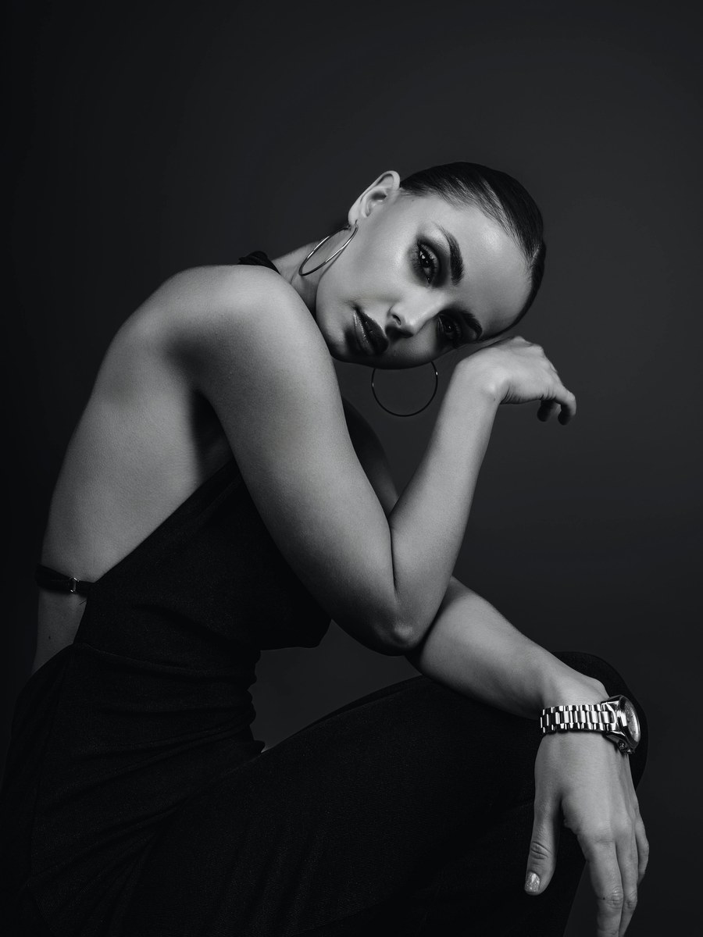 | [ photo pending ] | [ photo pending ]
FRONT — sample worn | SIDE — to follow | BACK — to follow
Front image: client D. Ashcombe in the basted sample, House studio, 14 Jul 2026. Side and back frames to be added at the second fitting.

Revisions for the next sample
Actions required before the second basted fitting. Numbering is Word-driven so the list renumbers automatically as items are added or removed.
- Re-mark waist suppression on side-body and back seams to recover 1.4 cm of shape; re-press the waist curve and confirm the fronts close over the hip.
- Re-cut the right sleeve to full length from the sleeve-head reserve and re-hang, correcting forward pitch in the same operation; leave the left sleeve untouched.
- Drop the gorge and re-set the collar to lower the break one button; re-press the lapel to a soft 3-roll-2 and verify the roll sits on the chest.
- Re-assess the front-quarter hem opening only after the waist is taken in; adjust the hem sweep to spec if the opening persists.
- Re-press the right shoulder-blade drag and confirm it releases once the sleeve is re-hung; check the scye for residual strain.
- Prepare side and back fit frames and a fresh half-measure sheet for all twelve POMs at the second fitting; carry this report for sign-off comparison.

Ownership & due dates
# | Action | Owner | Due
1 | Waist re-mark & re-press | T. Vane (Cutter) | 18 Jul 2026
2 | Right sleeve re-cut & re-hang | T. Vane (Cutter) | 18 Jul 2026
3 | Gorge / collar re-set | J. Ellory (Fitter) | 19 Jul 2026
4 | Hem sweep re-assess | A. Reeve (Tailor) | 20 Jul 2026
5 | Shoulder drag re-press | A. Reeve (Tailor) | 20 Jul 2026
6 | Frames & measure sheet prep | Studio | 21 Jul 2026

Sign-off
Role | Name | Signature | Date
Fitter | J. Ellory | x ____________________ | _________
Head Cutter | T. Vane | x ____________________ | _________
Client approval | D. Ashcombe | x ____________________ | _________
Return the corrected sample with this report attached. Second basted fitting to be scheduled on completion of the actions above.

