 | HALDEN & VANE  DESIGN & ENGINEERING STUDIO

PROPOSAL & STATEMENT OF WORK
Brand Website Rebuild
A digital flagship for Maison Solene
PREPARED FOR  Maison Solene  Theo Marchand  Head of Digital  theo.marchand@maisonsolene.com | PREPARED BY  Halden & Vane  Priya Anand  Engagement Lead  priya.anand@haldenvane.com

Project code HV-2026-071 Date 15 July 2026 Version v1.2
Confidential — prepared exclusively for Maison Solene. Valid for 30 days from the date above.
SECTION 01

Executive summary
Maison Solene has built a distinctive ready-to-wear voice, yet its current website — assembled on a templated platform in 2021 — no longer matches the quality of the collections it presents. Load times exceed six seconds on mobile, the storytelling is buried beneath rigid templates, and the content team cannot publish a lookbook without engineering support. The result is a flagship that undersells the brand and leaks revenue at every step of the journey.
Halden & Vane proposes a complete rebuild: a fast, editorial, headless website that puts imagery first, hands publishing control back to the Maison Solene team, and is engineered for accessibility and growth. This document sets out our approach, scope, timeline, team, commercial terms, and the acceptance criteria against which the work will be judged.
THE OUTCOME WE COMMIT TO
A production website launched in 13 weeks: sub-2-second mobile load, WCAG 2.2 AA accessibility, and a headless CMS that lets your team publish campaigns and lookbooks without a developer — targeting a 25–35% lift in mobile conversion within the first quarter.

Why now
The autumn/winter campaign launches in Q4. Rebuilding ahead of it means the new flagship carries your most important commercial moment of the year, and the content team enters campaign season with a platform they control rather than one they fight.
The pricing, timeline and team named in this proposal are reserved for Maison Solene through the validity window on the cover. We are ready to mobilise within one week of a signed statement of work.
SECTION 02

Background & objectives
The engagement was scoped across three discovery calls with your digital, creative and e-commerce leads in June 2026. Three themes surfaced consistently, and they frame everything that follows.
- Editorial-first experience. Make imagery and story the centre of gravity. The site should feel like the brand's magazine, not a catalogue grid.
- Autonomy for the content team. Give editors a headless CMS to compose campaigns, lookbooks and journal entries without engineering tickets.
- Performance & accessibility. Sub-2-second mobile load and WCAG 2.2 AA conformance, treated as launch gates rather than afterthoughts.
- A platform built to grow. A component system and clean data model that extend to new markets, languages and commerce features.

Approach & methodology
We work in four connected phases. Each ends in a tangible artefact and a decision gate, so you always know what has been delivered and what happens next.
- Discovery & content strategy. Stakeholder interviews, analytics and content audit, information architecture, and a measurement framework. Output: a validated sitemap and content model.
- Experience & interface design. Wireframes, an editorial design system, and high-fidelity prototypes for the key templates. Output: signed-off designs and a component library in Figma.
- Front-end build & CMS integration. Componentised React front end, headless CMS modelling, and migration of existing content. Output: a staged, reviewable build behind authentication.
- Quality, accessibility & launch. Cross-device QA, automated and manual accessibility testing, performance tuning, and a supervised go-live. Output: the production site and a handover pack.
SECTION 03

Scope of work
Scope is defined positively (what we will build) and negatively (what sits outside this statement of work). Anything not listed as in-scope is, by definition, out-of-scope and handled through the change process in the terms.

In scope
- Discovery, information architecture, and a documented content model.
- Responsive editorial design system covering home, collection, product, lookbook, journal, story and contact templates.
- Front-end build in React with server-side rendering for performance and SEO.
- Headless CMS setup, schema modelling, and editor training for up to six users.
- Migration of existing product and editorial content into the new model.
- Accessibility (WCAG 2.2 AA) and performance engineering to the launch gates.
- Analytics and consent instrumentation, plus a supervised production launch.

Out of scope
- Brand identity, logo or photography art direction (we consume existing assets).
- Net-new product photography or video production and post-production.
- Replatforming of the commerce back end or payment provider.
- Ongoing content authoring and campaign production after launch.
- Paid media, SEO retainer, or performance-marketing services.

Key deliverables
Deliverable | Description | Acceptance criteria
Content model & IA | Sitemap, content schema and migration map | Approved by digital lead; covers all template types
Editorial design system | Figma component library and key page designs | Signed-off designs; tokens documented and reusable
Production front end | React SSR build integrated with the CMS | All templates live on staging; Lighthouse ≥ 90
Headless CMS | Configured schemas, roles and editor training | Six editors trained; publish a campaign unaided
Launch & handover | Production go-live plus documentation pack | Site live; runbook and 2-week warranty accepted
SECTION 04

Timeline & milestones
The programme runs over 13 weeks from kickoff to go-live. Phases overlap where handovers allow, and four milestones act as formal decision gates. The strip below shows the phase plan against project weeks; milestones are marked as diamonds.
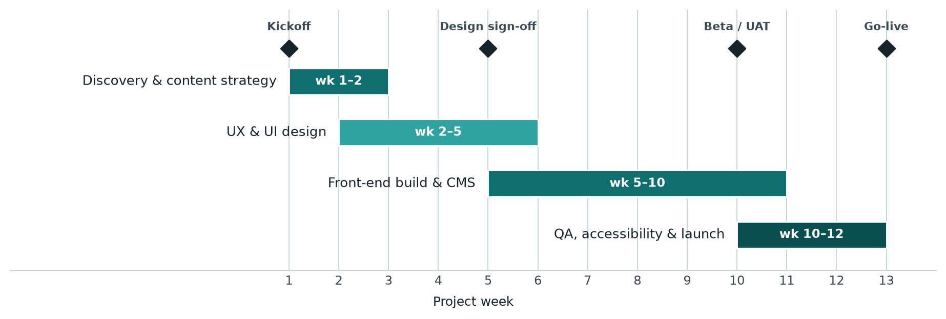
Figure 1. Phase plan and milestone gates across the 13-week programme.

Milestone schedule
Milestone | Timing | Gate description
M1 — Kickoff | Week 1 | Mobilisation, access, and discovery workshops begin
M2 — Design sign-off | Week 5 | Editorial design system and key templates approved
M3 — Beta / UAT | Week 10 | Full build on staging; client user-acceptance testing
M4 — Go-live | Week 13 | Production launch, warranty period and handover
Dates assume a signed statement of work by the end of July 2026 and timely access to content, brand assets and stakeholder availability for reviews. Slippage on client-side approvals shifts dependent dates by the same interval.
SECTION 05

Team & commercials

Core team
Name | Role | Allocation
Priya Anand | Engagement lead | 20%
Marcus Reeve | UX & content director | 40%
Ines Falk | Lead editorial designer | 60%
Daniel Cho | Principal front-end engineer | 80%
Sofia Reyes | QA & accessibility specialist | 30%

Pricing
Line item | Qty | Rate | Amount
Discovery & content strategy | 1 | €18,000 | €18,000
Experience & interface design | 1 | €32,000 | €32,000
Front-end build (React SSR) | 1 | €38,000 | €38,000
Headless CMS integration & migration | 1 | €22,000 | €22,000
QA, accessibility & launch | 1 | €12,000 | €12,000
Total (fixed price, excl. VAT) |  |  | €122,000

Payment schedule
Milestone | Share | Amount
On signature (mobilisation) | 20% | €24,400
Design sign-off (M2) | 30% | €36,600
Beta / UAT (M3) | 30% | €36,600
Go-live & acceptance (M4) | 20% | €24,400
Total | 100% | €122,000
SECTION 06

Assumptions, terms & sign-off

Assumptions
- Brand assets, photography and copy are supplied by Maison Solene in usable formats.
- A single client decision-maker consolidates and returns feedback within five working days per gate.
- The existing commerce back end exposes a stable API for product data.
- Third-party licences (fonts, CMS, hosting) are procured in the client's name.

Terms
- This is a fixed-price engagement; the fee covers the scope defined in Section 3. Changes are handled by written change request, estimated and approved before work begins.
- Invoices are issued against the payment schedule and due within 30 days. Work may pause on overdue invoices beyond 15 days.
- Intellectual property in delivered code and designs transfers to Maison Solene on final payment; Halden & Vane retains the right to reference the work in its portfolio.
- Each deliverable is deemed accepted when its acceptance criteria are met, or five working days after delivery absent written objection.
- A two-week warranty covers defects after go-live. Either party may terminate for material breach on 15 days' written notice; work delivered to date is payable.

Acceptance & sign-off
Signing below indicates agreement to this proposal and statement of work, including the scope, timeline, pricing and terms set out above.
FOR THE CLIENT Maison Solene  Signature  Name and title  Date  Theo Marchand — Head of Digital | FOR THE AGENCY Halden & Vane  Signature  Name and title  Date  Priya Anand — Engagement Lead

