LUMEN & FOX · SUPPLIER QUALITY
AQL Inspection Report
Final Random Inspection (FRI) — ISO 2859-1, Single Sampling, Normal Severity

1. Inspection Summary
INSPECTION SUMMARY — Style LF-2611 · PO-LF-4471
Report ID | QC-LF2611-2607 | Inspection date | 26 Jul 2026
Inspector | Rafiq Haque (SGS BD) | Inspection type | Final Random (FRI)
Brand | Lumen & Fox | Buyer PO # | PO-LF-4471
Factory | Dhaka Apparel Mills Ltd. | Factory ref | DAM-2026-0713
Style # | LF-2611 | Style name | Poplin Shirt
Order qty | 1,200 pcs | Lot size presented | 1,200 pcs
Colourways | White · Sky · Clay | Size range | S – XXL
Inspection level | General II (GII) | Sample-size code | J
Sample size (n) | 80 pcs | Sampling plan | Single · Normal
AQL — Major | 2.5 (Ac 5 / Re 6) | AQL — Minor | 4.0 (Ac 10 / Re 11)
Table 1. Lot 1,200 units accepted on majors (3 ≤ Ac 5) and minors (2 ≤ Ac 10) — overall verdict ACCEPTED.

Sampling plan — derivation (ISO 2859-1)
The presented lot of 1,200 finished units was inspected under ISO 2859-1 at General Inspection Level II (GII), single sampling, normal severity. The plan below is read directly from the standard's code-letter and single-sampling master tables — it is not chosen by the inspector:
- Lot size 1,200 falls in the ISO 2859-1 range 501–1,200. At General Inspection Level II this range maps to sample-size code letter J.
- Code letter J on the single-sampling master table (normal severity) specifies a sample of n = 80 units, drawn at random across cartons and sizes.
- At AQL 2.5 (major defects) the acceptance / rejection numbers for n = 80 are Ac 5 / Re 6 — accept the lot on majors if 5 or fewer are found, reject at 6.
- At AQL 4.0 (minor defects) the numbers for n = 80 are Ac 10 / Re 11 — accept on minors at 10 or fewer, reject at 11.
- Disposition rule: the lot is ACCEPTED only when both criteria pass (majors ≤ 5 AND minors ≤ 10). This inspection found 3 majors and 2 minors — both within acceptance — so the lot is ACCEPTED subject to the corrective actions in §5.

2. Defect Log
Five defects were recorded across the 80-piece sample — three classified MAJOR (against AQL 2.5) and two MINOR (against AQL 4.0). Found totals: majors 3 (≤ Ac 5), minors 2 (≤ Ac 10). Severity follows the Lumen & Fox classification manual §4.
# | Defect description | Location | Severity | Qty | Photo | Note
1 | Broken / loose stitching at front placket | Front placket | MAJOR | 1 | IMG-01 | Line 4 — operator retraining (CA-01)
2 | Skipped stitches, side seam (open > 2 cm) | Side seam, LH | MAJOR | 1 | IMG-02 | ESCALATED · watch — seam-strength recheck on next lot
3 | Oil contamination stain (~8 mm) | Left cuff | MAJOR | 1 | IMG-03 | Spot-clean; audit machine oiling schedule
4 | Untrimmed thread ends | Inside hem | MINOR | 1 | IMG-04 | Trim at final QC before packing
5 | Main label off-centre (~3 mm) | Neck / collar | MINOR | 1 | IMG-05 | Within re-work tolerance; re-press
Table 2. Defect register — one MAJOR (IMG-02) escalated to a next-lot watch on seam strength.
Legend: MAJOR = functional / saleability defect against AQL 2.5. MINOR = cosmetic / re-workable defect against AQL 4.0.
Analysis. Majors cluster on the sewing floor (placket, side seam), not on cutting or fabric — so the corrective effort in §5 targets Line 4 stitching and machine oiling rather than the fabric supplier. The escalated side-seam defect (IMG-02) is the only one carried forward as a next-lot watch because open seams affect wearer safety and can recur if seam-strength drifts.

3. Visual Evidence & Measurements
3.1 Photo evidence
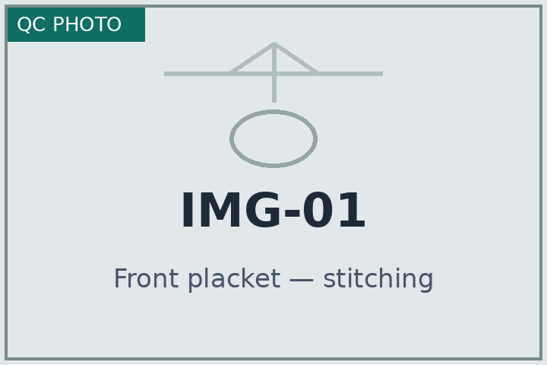  IMG-01 Front placket — stitching | 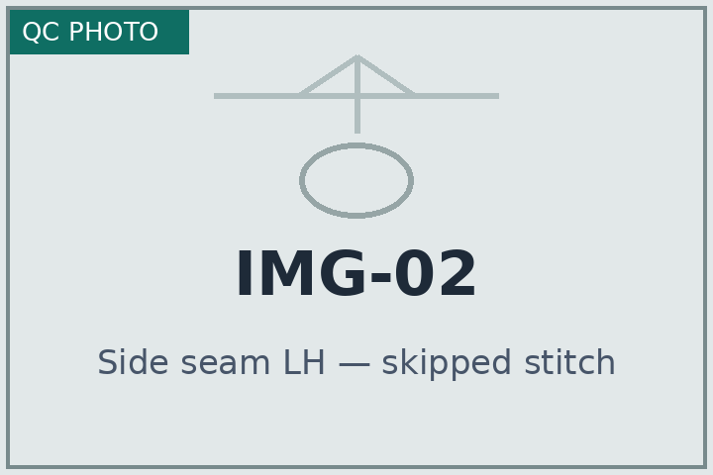  IMG-02 Side seam LH — skipped stitch | 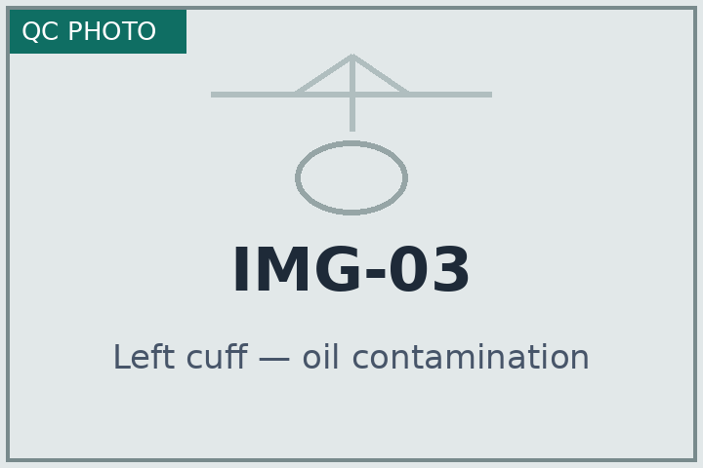  IMG-03 Left cuff — oil stain
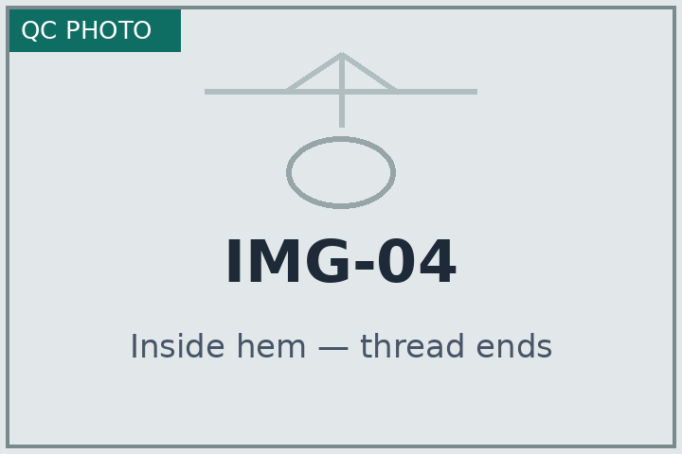  IMG-04 Inside hem — thread ends | 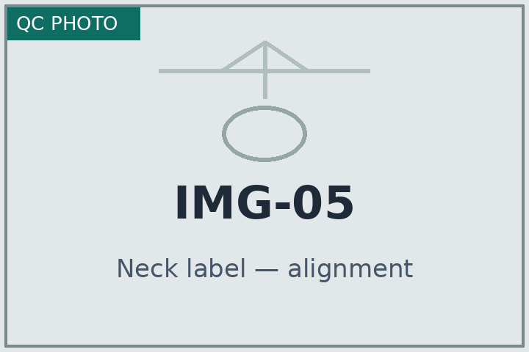  IMG-05 Neck label — alignment | 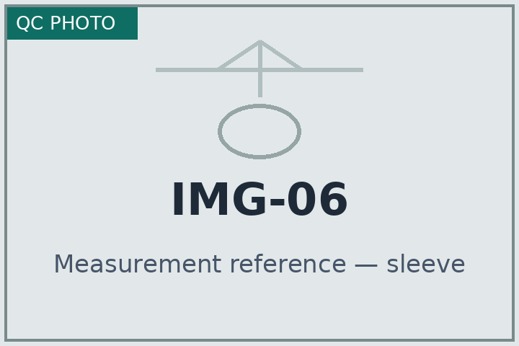  IMG-06 Sleeve length — measure ref.
Figure 1. Representative inspection photographs (labeled tiles — sample evidence set, 6 of 22 captured).
3.2 Measurement check — points of measure (cm)
Point of measure | Spec | Tol ± | Measured | Deviation | Status
Chest width (½, 2.5 cm below armhole) | 58.0 | ±1.0 | 58.4 | +0.4 | OK
Body length (from HPS) | 78.0 | ±1.5 | 77.2 | −0.8 | OK
Sleeve length (CB to cuff) | 62.5 | ±1.0 | 64.0 | +1.5 | OUT
Shoulder width (seam to seam) | 46.0 | ±0.8 | 45.7 | −0.3 | OK
Bottom hem width (½) | 60.0 | ±1.0 | 59.5 | −0.5 | OK
Collar height (CB) | 6.5 | ±0.3 | 6.6 | +0.1 | OK
Table 3. Sleeve length is +1.5 cm over the ±1.0 cm tolerance (OUT) — logged as a measurement non-conformance; factory to verify sleeve pattern and re-measure before shipment (tracked in §5).

4. Packing & Labeling Checklist
Ten packing and labeling points were verified against the PO-LF-4471 packing manual. Eight conform; two are open and carried to the corrective-action register (§5).
- ☑ Master carton dimensions & gross weight match the packing list OK
- ☑ Carton markings — shipping marks and side marks legible and correct OK
- ☑ Polybag carries suffocation warning and scannable barcode OK
- ☑ Care label — fibre content and wash symbols correct for style OK
- ☑ Country-of-origin label “Made in Bangladesh” present and sewn OK
- ☑ Brand main label centred, straight and correct size variant OK
- ☐ Hangtag price / SKU matches PO OPEN — 4 cartons carried EU price hangtags on US-bound units — see CA-02
- ☑ UPC / GS1 barcode scans on first pass OK
- ☑ Size-assortment ratio per carton matches PO breakdown OK
- ☐ Inner polybag desiccant / moisture control per spec OPEN — Silica sachets missing in 6 of 80 sampled polybags — see CA-03

Lot disposition — computed result
Class | AQL | Found | Ac | Re | Result
Major defects | 2.5 | 3 | 5 | 6 | PASS
Minor defects | 4.0 | 2 | 10 | 11 | PASS
Decision rule: ACCEPT if majors ≤ Ac 5 AND minors ≤ Ac 10. Observed 3 and 2 — both within acceptance.
✓ LOT ACCEPTED
Lot 1,200 units · Style LF-2611 · PO-LF-4471 — released for shipment,
subject to closure of CA-02 and CA-03 before the 02 Aug 2026 ship date.

5. Corrective-Action Register
Three corrective actions were raised from the defect log, the out-of-tolerance measurement and the two open packing points. All are open at time of report and must be verified before the 02 Aug 2026 ship date.
CA # | Finding | Action | Owner | Due | Verification / status
CA-01 | Broken / loose stitching at front placket (MAJOR, 1 pc) + sleeve length +1.5 cm over tolerance | Retrain Line 4 operators; 100% re-check placket seam and re-measure sleeve pattern | M. Alam (Factory QA) | 30 Jul 2026 | Re-inspection AQL 2.5 · OPEN
CA-02 | EU price hangtags found on 4 US-bound cartons | Sort and re-tag affected cartons; segregate and re-scan mixed cartons | S. Rahman (Packing) | 29 Jul 2026 | Photo evidence + barcode re-scan · OPEN
CA-03 | Desiccant sachets missing in 6 of 80 sampled polybags | Add silica per spec; re-audit polybag line and moisture-control step | S. Rahman (Packing) | 29 Jul 2026 | Re-sample 80 polybags · OPEN
Table 4. Corrective-action register — verification closes each item; the lot ships once CA-02 and CA-03 are confirmed.

Sign-off
INSPECTOR  Rafiq Haque  Lead QC Inspector, SGS Bangladesh  Date: 26 Jul 2026 | FACTORY REPRESENTATIVE  Mahfuz Alam  QA Manager, Dhaka Apparel Mills Ltd.  Date: 26 Jul 2026 | BRAND QA  Elena Voss  Senior QA, Lumen & Fox  Date: 27 Jul 2026
End of report — QC-LF2611-2607. Prepared by McLeuker AI on behalf of Lumen & Fox Quality Assurance. This inspection reflects the sample examined on 26 Jul 2026 and does not transfer product liability.

