Standard Operating Procedure
E-commerce Order Fulfilment & Dispatch
Document control | SOP-FUL-014 — E-commerce Order Fulfilment & Dispatch
Version | 3.2
Effective date | 15 July 2026
Owner | Head of Fulfilment Operations
Approver | Director, Supply Chain
Classification | Internal — Controlled
Review cycle | Annual — next review July 2027

1 Purpose
This procedure defines the controlled, repeatable method by which Nordlis Commerce B.V. receives, picks, packs and dispatches direct-to-consumer e-commerce orders from Distribution Centre North (DC-NL-01). It exists to protect order accuracy, carrier service-level compliance and traceability of every consignment from order release to carrier handover.

2 Scope
Applies to all apparel and accessory orders (SKU family NRD-*) fulfilled from DC-NL-01 through the warehouse management system (WMS). It covers single- and multi-line orders, standard and expedited service, and the exception handling triggered by stock, quality or data discrepancies. It excludes wholesale bulk shipments, inbound goods receipt (see SOP-INB-002) and returns processing (see SOP-RET-009), which are governed separately.

3 Definitions & abbreviations
The following terms are used throughout this procedure.
Term | Definition
WMS | Warehouse Management System — the system of record for stock location, pick tasks and dispatch.
OMS | Order Management System — receives web orders and releases them to the WMS.
SKU | Stock-Keeping Unit; Nordlis format NRD-<season>-<style>, e.g. NRD-AW26-04731.
ASN | Advance Shipping Notice — carrier pickup manifest transmitted before handover.
Pick face | Fixed forward location from which an operative picks a SKU to a tote.
Wave | A grouped batch of orders released together for efficient picking.
SLA | Service-Level Agreement — the same-day dispatch cut-off (16:00 CET).
RTS | Return-to-Stock — controlled put-away of a picked item after a cancellation.

4 Roles & responsibilities
Responsibilities are assigned per the RACI matrix below (R = Responsible, A = Accountable, C = Consulted, I = Informed).
Activity | Ful. Op. | Team Lead | QC Insp. | Dispatch | Ops Mgr
Order release & wave planning | I | R | I | I | A
Pick to tote | R | A | I | I | I
Pack & SKU verification | R | A | C | I | I
Quality / discrepancy check | C | C | R | I | A
Weigh, label & manifest | R | A | I | C | I
Dispatch handover to carrier | I | C | I | R | A
Exception & escalation handling | C | R | C | C | A

5 Procedure
Each step is performed in sequence. Numbering is controlled; do not skip steps. Where a decision point applies, follow the stated IF/THEN branch.
  - Receive & validate order
    - Confirm the order has flowed from the OMS to the WMS and carries a valid shipping address and service level.
    - Verify payment status is CLEARED. IF payment is flagged HOLD, THEN do not release the order and escalate per §7.1.
    - Confirm every line SKU (NRD-*) has available-to-promise stock in the WMS.
  - Wave planning & pick-list release
    - Group validated orders into a pick wave by carrier cut-off and zone.
    - Release the wave; the WMS generates sequenced pick tasks to tote.
  - Pick to tote
    - Travel to each pick face in the WMS-directed sequence.
    - Scan the location barcode, then scan the SKU; the WMS confirms the match.
    - Place the item in the assigned tote and confirm the quantity.
    - IF the scanned SKU or on-hand quantity does not match the pick task, THEN stop, do not substitute, and raise a stock-mismatch exception per §7.2.
  - Pack, verify & weigh
    - Re-scan every item against the packing list to confirm SKU and quantity.
    - Select carton size by cube; add void fill to the fill line.
    - Weigh the sealed carton and record the actual weight in the WMS.
    - IF the actual weight deviates more than 10% from the expected weight, THEN re-verify contents before proceeding.
  - Print label & carrier manifest
    - Print the carrier shipping label and affix it to the largest flat face.
    - Confirm the consignment is added to the carrier ASN / manifest.
  - Dispatch handover
    - Stage the sealed, labelled carton in the carrier lane by cut-off.
    - Hand over against the ASN and capture the carrier scan as proof of dispatch.
    - Confirm the WMS status advances to SHIPPED; the OMS notifies the customer.
The WMS pick-confirmation screen guides each pick and scan step above.

Figure 1. Sample — illustrative WMS pick-station reference image (placeholder for the live pick screen).

6 Process flow
The flowchart below mirrors the numbered steps in §5, including the stock-match decision and the exception loop back to order validation.
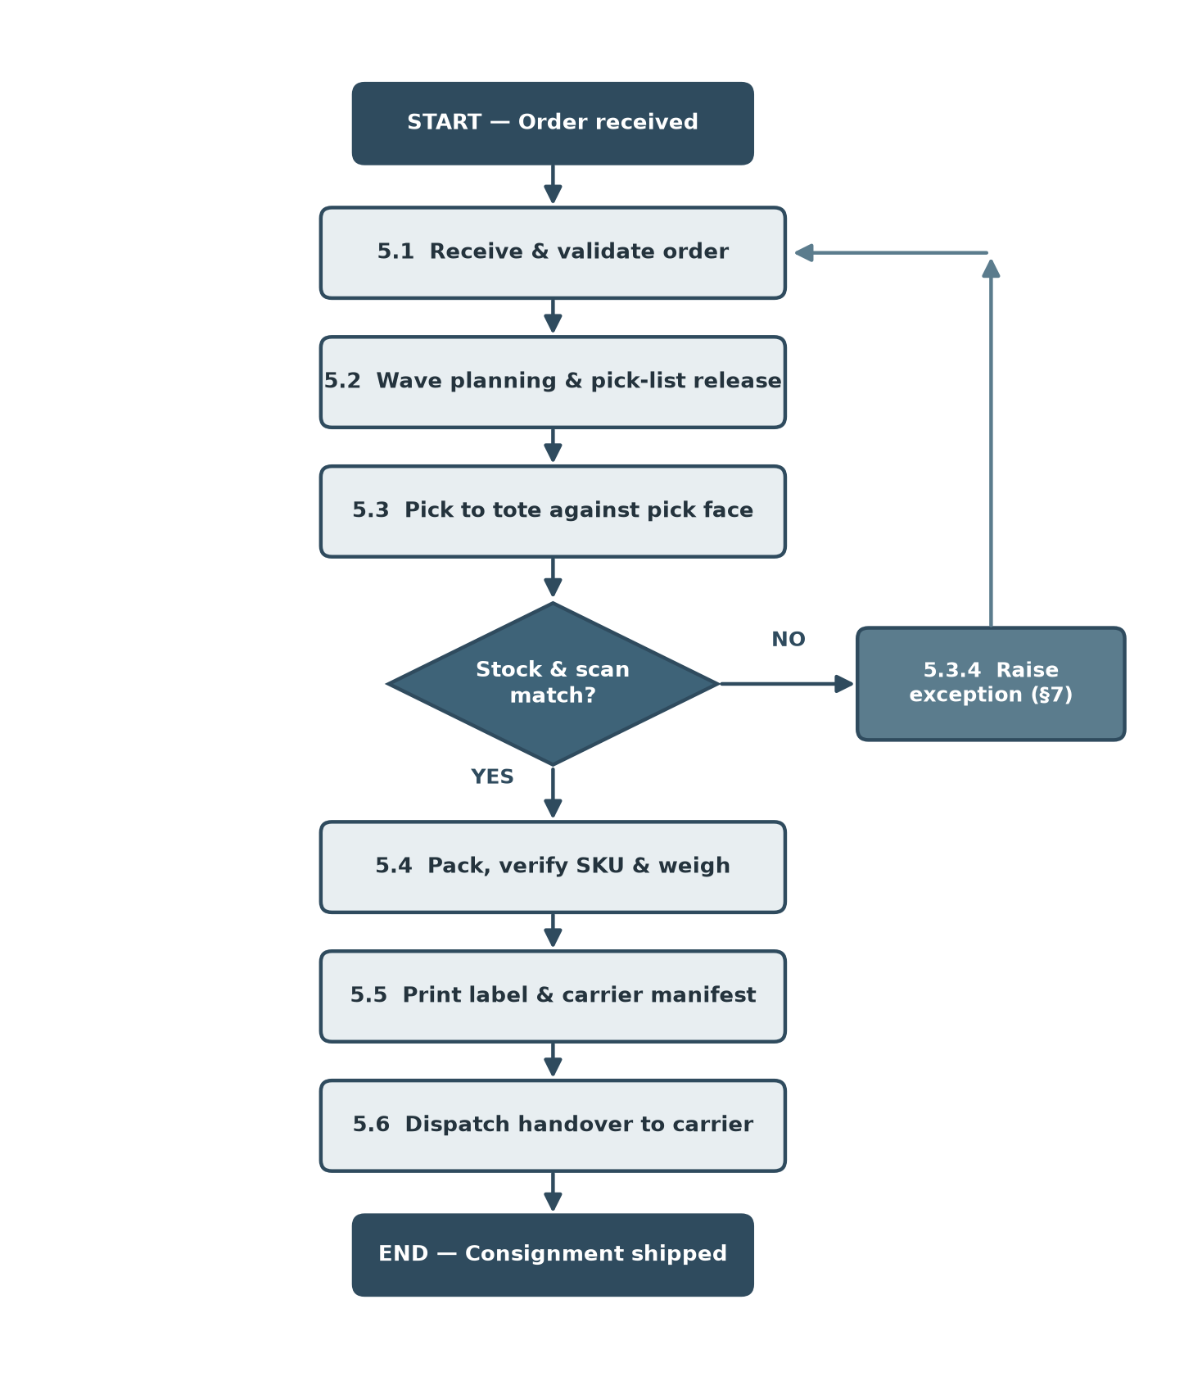
Figure 1. Order fulfilment & dispatch process flow (§5 steps with stock-match decision and §7 exception path).

7 Exceptions & escalation
Exceptions halt the standard flow and are logged in the WMS exception queue. Resolve per the routes below.
  - Payment hold. Retain the order; notify Ops Manager; release only after Finance clears the flag. Target resolution: 4 working hours.
  - Stock mismatch. Quarantine the tote; QC Inspector reconciles physical vs system stock; adjust WMS on-hand and re-plan the line. Escalate to Ops Manager if unresolved within 2 hours.
  - Damaged item at pack. Route the item to RTS or scrap per QC disposition; re-pick a replacement from available stock.
  - Missed carrier cut-off. Re-book to the next available service and inform the customer of the revised dispatch date.

8 Related documents
- SOP-INB-002 — Inbound Goods Receipt & Put-away
- SOP-RET-009 — Returns Processing & Return-to-Stock
- WI-PACK-004 — Packing & Void-Fill Work Instruction
- POL-QA-001 — Quality Assurance Policy

9 Revision history
Version | Date | Author | Change summary
1.0 | 12 Mar 2024 | J. Bakker | Initial issue.
2.0 | 08 Jan 2025 | J. Bakker | Added wave planning; RACI matrix.
3.0 | 19 Nov 2025 | M. de Vries | Restructured procedure to §5 multi-level.
3.2 | 15 Jul 2026 | M. de Vries | Updated SLA cut-off; added exception loop.

