WEB CONTENT BRIEF
New Arrivals — Category Page
Brief for the women's New Arrivals landing page on meridian.com. Hand this to a copywriter and designer to execute end-to-end.

Brief summary
Field | Detail
Page | Women's New Arrivals — category landing page
URL slug | meridian.com/womens/new-arrivals
Owner | R. Okafor (Content) · L. Brandt (Design)
Due date | Fri 24 Jul 2026 — copy v1 to design
Status | In progress — awaiting merchandising sign-off
Primary goal | Drive discovery of new-season stock; lift category CTR and add-to-cart rate

SEO basics
Target keywords, metadata and on-page heading. Character counts are live — keep the title ≤ 60 and the description ≤ 160 so neither truncates in search results.
Element | Value | Length
Target keyword(s) | women's new arrivals, new season clothing, latest fashion drops | —
Meta title | New Arrivals in Women's Fashion | MERIDIAN | 42 chars
Meta description | Shop women's new arrivals at MERIDIAN. Fresh-season dresses, knitwear and tailoring, restocked every Thursday. Free 30-day returns. | 131 chars
URL slug | /womens/new-arrivals | —
H1 recommendation | New Arrivals: This Week's Edit | 30 chars
Title and description are within limits; do not pad to fill the count. Primary keyword sits in the first 60 characters of the description.

Page structure
Build the page in this order, top to bottom. Each numbered block below gives its purpose, a draft headline, body direction, the CTA and the media slot to fill.
- Hero
Purpose | Set the season and pull visitors into the edit within the first screen.
Headline (draft) | “Just In: This Week's Edit”
Body direction | One line of context, max 12 words. Name the season and the mood, not the product count.
CTA | Shop the edit → (anchors to product grid)
Media slot | Full-bleed campaign image — see sample below.
- Intro copy
Purpose | Orient the shopper and land the primary keyword naturally.
Headline (draft) | “New in this week”
Body direction | 40–60 words. Lead with the keyword ‘new season clothing’ in sentence one; editorial, not salesy.
CTA | Inline link: ‘browse by category’
Media slot | None — text block only.
- Product grid
Purpose | The core of the page — fast, scannable new stock.
Headline (draft) | “The new arrivals”
Body direction | Default sort = newest. 3-up on desktop, 2-up mobile. Show ‘New’ badge on the last 14 days of stock.
CTA | Quick-add on hover; ‘Load more’ at row 4.
Media slot | Product tiles (dynamic) — no static asset.
- Editorial block
Purpose | Break the grid; add styling context and dwell time.
Headline (draft) | “How we're wearing it”
Body direction | Short styling note (30–40 words) tied to 2–3 hero products. Link each callout to its PDP.
CTA | ‘Get the look’ → curated set
Media slot | 1 editorial lifestyle image, portrait.
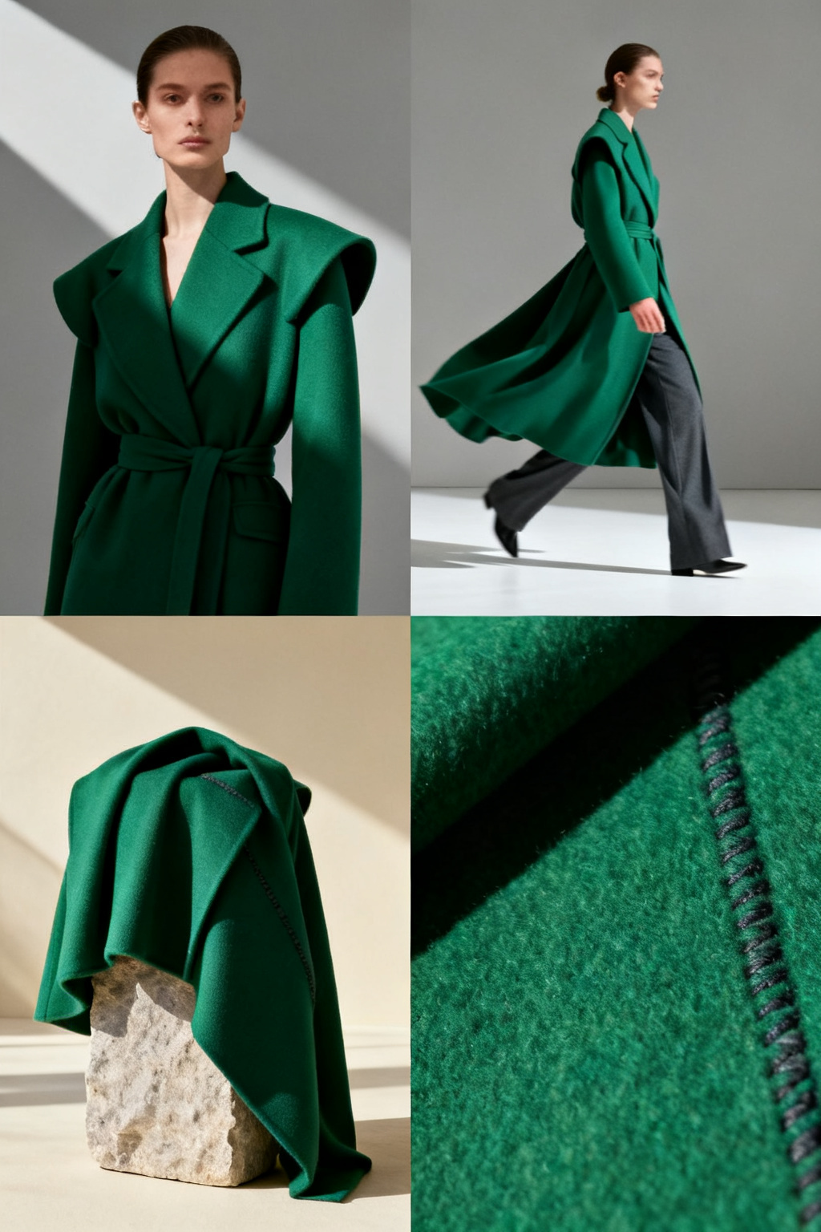
Sample media reference — editorial lifestyle plate (campaign asset, place at 4:5 portrait).
- Size guide
Purpose | Remove the top pre-purchase doubt without leaving the page.
Headline (draft) | “Find your fit”
Body direction | One-line reassurance + expandable fit table. Keep collapsed by default.
CTA | ‘Open size guide’ (accordion)
Media slot | Icon + inline fit table.
- Reviews
Purpose | Social proof close to the point of decision.
Headline (draft) | “Loved by our community”
Body direction | Aggregate star rating + 2–3 short quotes on recent arrivals. Pull live from the reviews API.
CTA | ‘Read all reviews’
Media slot | Star glyphs + optional customer photo.
- CTA / footer band
Purpose | Capture intent and hand off to the next best action.
Headline (draft) | “First to know, first to shop”
Body direction | Newsletter sign-up with the new-drop cadence (‘every Thursday’) as the hook.
CTA | ‘Sign up’ + ‘Continue shopping’
Media slot | Solid lime band, no image.

Tone of voice
Confident, editorial, warm. Speak like a stylist who knows the collection — never like a discount banner.
DO | DON'T
Lead with the product and the styling idea. | Open with the offer or a discount hook.
Short, active sentences; one idea each. | Stacked adjectives and hype (‘amazing’, ‘must-have’).
Name fabrics, cuts and the occasion. | Vague filler (‘elevate your wardrobe’).
Use ‘new in’ / ‘just landed’ for freshness. | Overuse exclamation marks or ALL CAPS.
Keep it inclusive and body-neutral. | Assume one body type or occasion.

Internal linking
Link out to these destinations with the exact anchor text shown — helps crawl depth and cross-sells the catalogue.
- ‘shop new dresses’ → /womens/dresses
- ‘new-season knitwear’ → /womens/knitwear
- ‘back in stock’ → /womens/back-in-stock
- ‘read the season edit’ → /editorial/season-edit
- ‘full size guide’ → /customer-care/size-guide

Conversion elements
- Trust signals: free 30-day returns, secure checkout and a delivery estimate visible above the fold.
- Urgency (honest only): ‘new drops every Thursday’ and low-stock flags on the last few units — never fake countdowns.
- Frictionless: quick-add to bag, guest checkout and a persistent ‘view bag’ affordance.
- Reassurance near CTA: returns policy and payment options repeated at the footer band.

Accessibility
Ship the page to WCAG 2.1 AA. Treat this as a build checklist — every item is a pass/fail gate before launch.
☐ Alt text on every image: describe the garment and context (‘model in olive linen blazer, front view’), not ‘image1.jpg’. Decorative bands get empty alt.
☐ Colour contrast ≥ 4.5:1 for body text; the lime accent is background-only — never lime text on white.
☐ Headings in order (one H1, then H2/H3, no skips) so screen readers and SEO share one outline.
☐ Tap targets ≥ 44×44 px with visible focus states on every link, filter and add-to-bag control.
☐ Grid is keyboard-navigable; quick-add reachable without a hover.
☐ Respect prefers-reduced-motion — no autoplay on the hero.

Measurement
Review weekly for the first month post-launch. Source of truth in brackets — no metric without an owner system.
Metric | Target | Source
Category page CTR (to PDP) | ≥ 18% | GA4 — events
Add-to-cart rate | ≥ 6.5% | GA4 — ecommerce
Avg. time on page | ≥ 45s | GA4 — engagement
Bounce rate | ≤ 40% | GA4 — engagement
Organic entrances | +15% MoM | Search Console
Newsletter sign-ups | ≥ 120 / wk | ESP dashboard
Questions on this brief → R. Okafor, Content team, MERIDIAN.

